Changes to bring @ [www.hospitalbanai.com](http://www.hospitalbanai.com) webpage

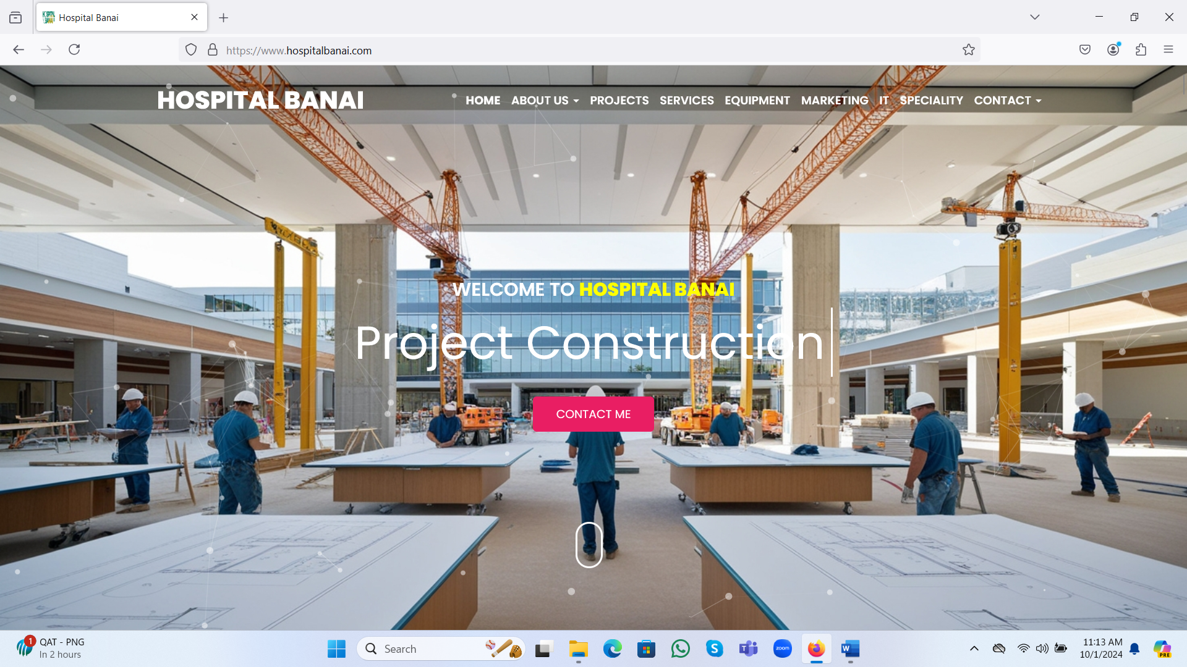

Write “A comprehensive (3600) healthcare sector/business advisory company” just below Welcome to Hospital Banai. Project implementation, construction, sales/marketing etc. would be shown below the sentence “A comprehensive (3600) healthcare sector/business advisory company” as it is showing now.

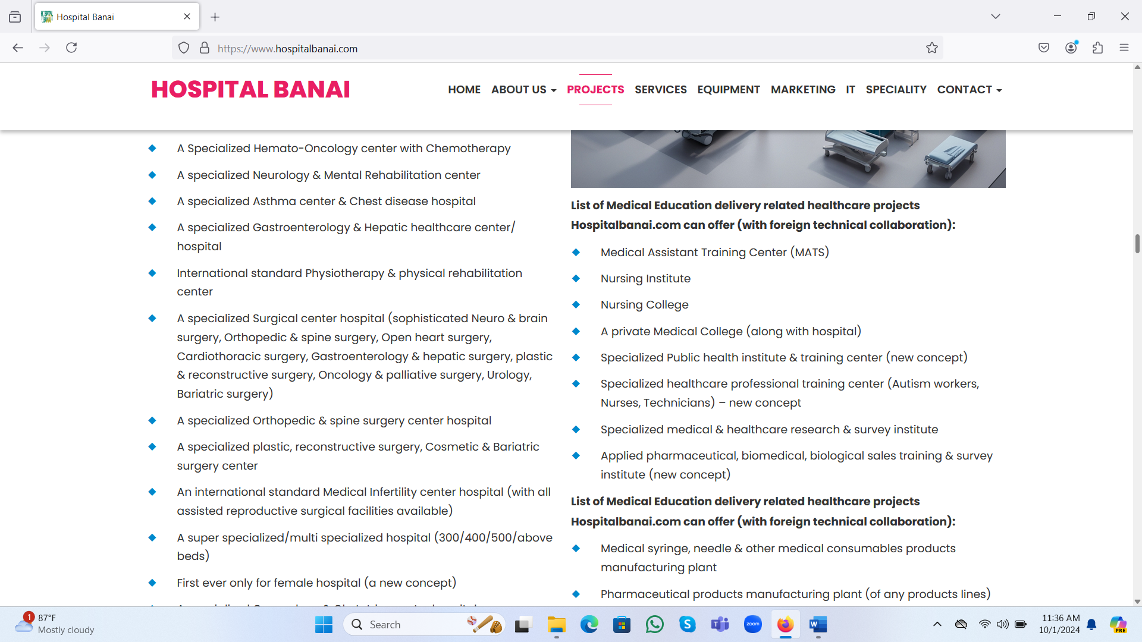

List of Medical Education delivery related healthcare projects Hospitalbanai.com can offer (with foreign technical collaboration): X Just remove “With foreign technical collaboration”

It would be “List of Medical Education delivery related healthcare projects Hospitalbanai.com can offer”

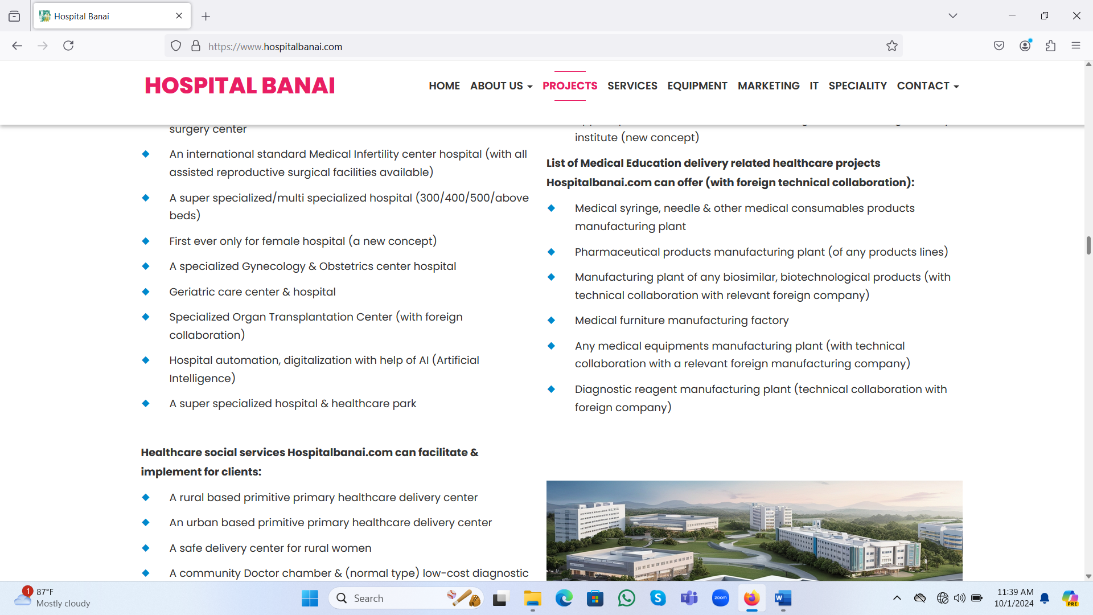

List of Medical Education delivery related healthcare projects Hospitalbanai.com can offer (with foreign technical collaboration): XXX These are Biomedical equipment’s/furniture/pharma products related projects

Write “List of Biomedical equipment/furniture/pharma products delivery related projects Hospitalbanai.com can offer”

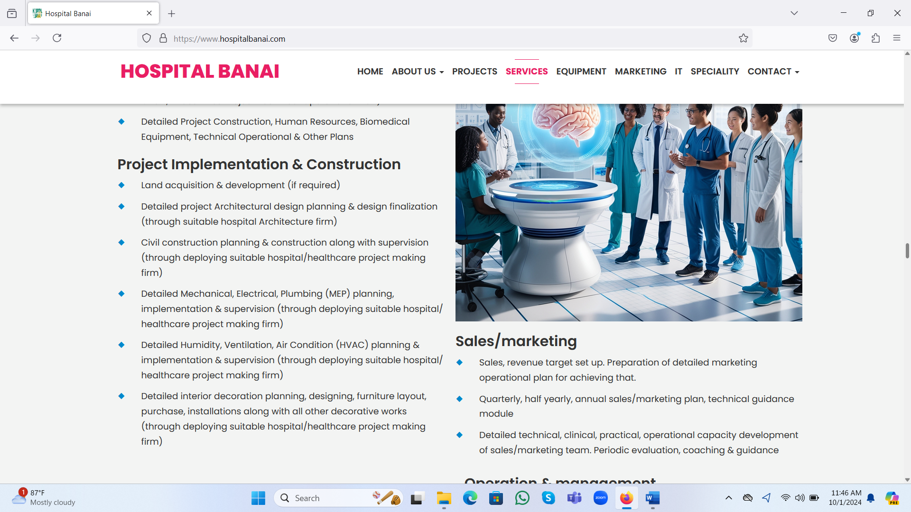

In the “Project Implementation & Construction” part bring these changes –

* Detailed project Architectural design planning & design finalization (through suitable hospital Architecture firm) XXX

Just write “Detailed project Architectural design planning & design finalization”

* Civil construction planning & construction along with supervision (through deploying suitable hospital/healthcare project making firm) XXX

Just write “Civil construction planning & construction along with supervision”

* Detailed Mechanical, Electrical, Plumbing (MEP) planning, implementation & supervision (through deploying suitable hospital/healthcare project making firm) XXX

Just write “Detailed Mechanical, Electrical, Plumbing (MEP) planning, implementation & supervision”

* Detailed Humidity, Ventilation, Air Condition (HVAC) planning & implementation & supervision (through deploying suitable hospital/healthcare project making firm) XXX

Just write “Detailed Humidity, Ventilation, Air Condition (HVAC) planning & implementation & supervision”

* Detailed interior decoration planning, designing, furniture layout, purchase, installations along with all other decorative works (through deploying suitable hospital/healthcare project making firm) XXX

Just write “Detailed interior decoration planning, designing, furniture layout, purchase, installations along with all other decorative works”

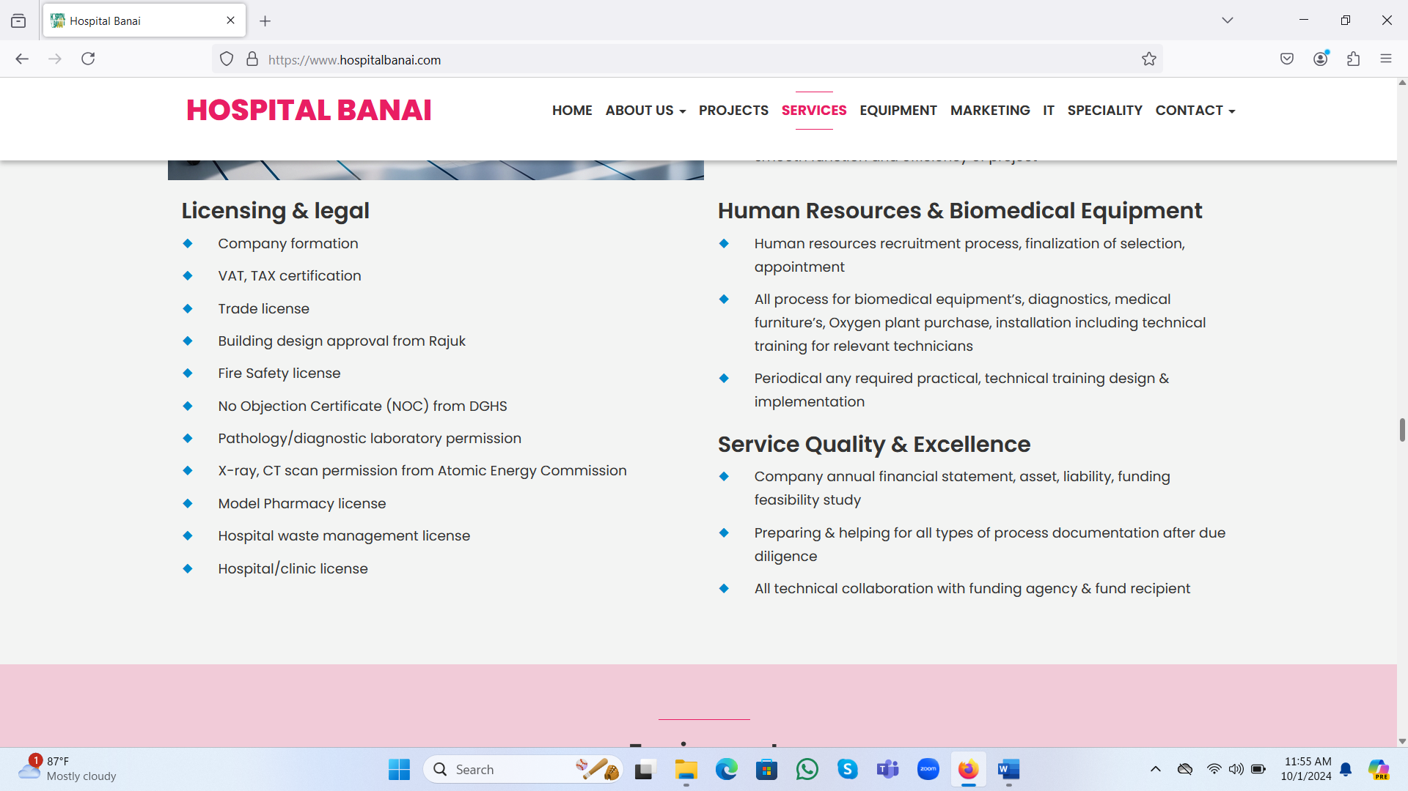

X-ray, CT scan permission from Atomic Energy Commission XXX

Write “Xray, Ct Scan, Mammography, Dental OPG permission from Atomic Energy Commission”

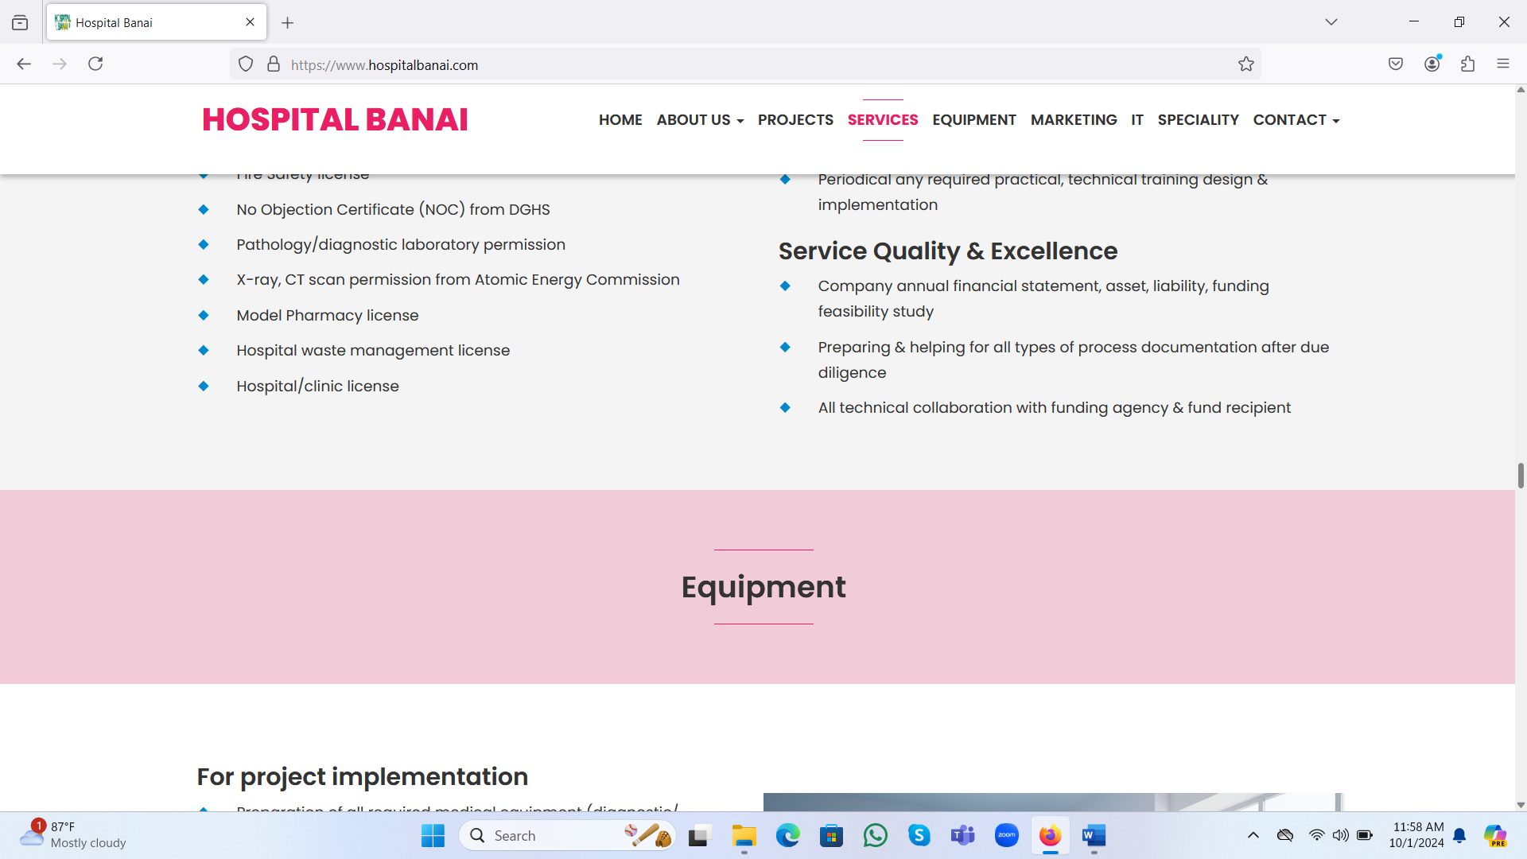

Service quality & Excellence (broad heading) XXX

It would be “Project Financing”

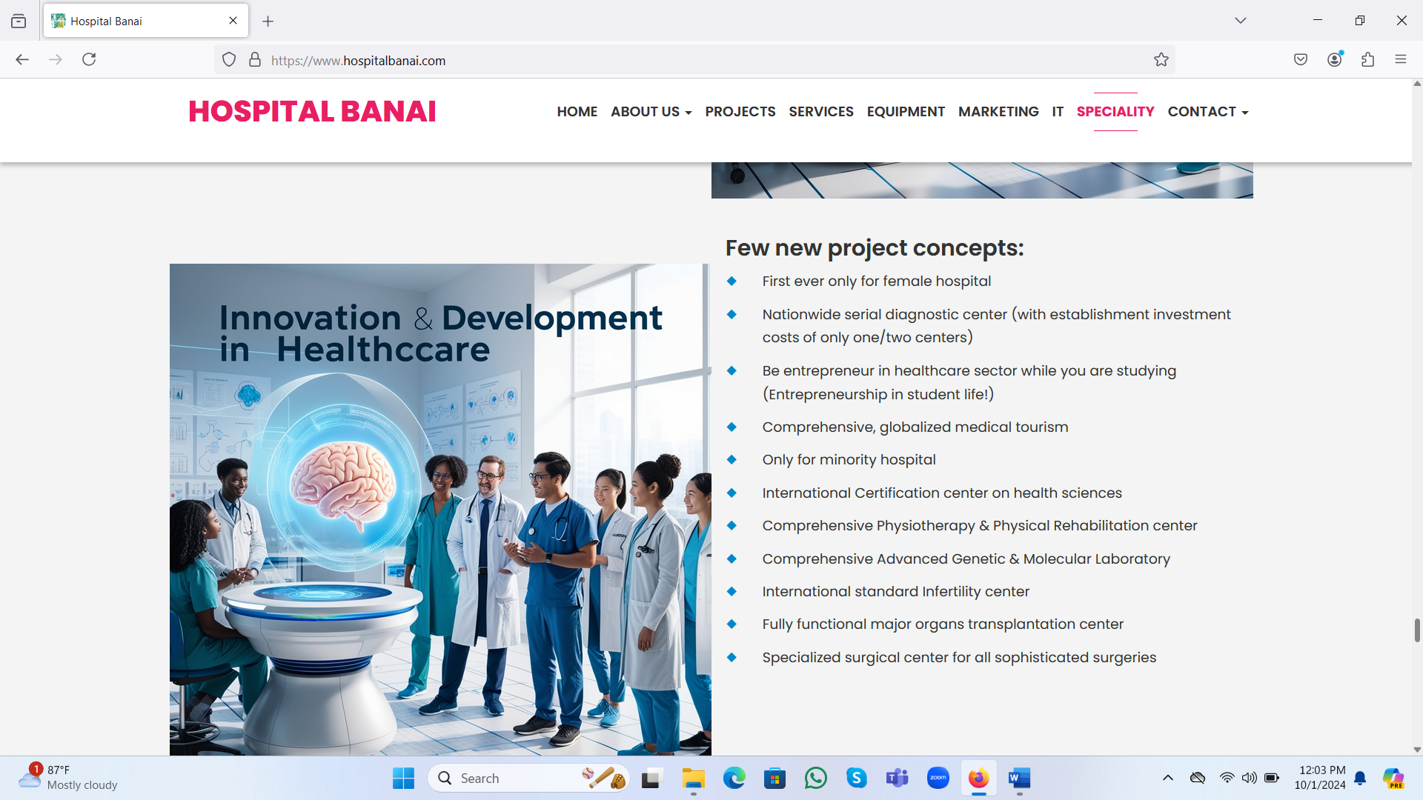

Add this entire part which is completely missed below the part “Few new project concepts”

***Why we stand separate in healthcare consultancy?***

* We focus on client’s mission, vision, expectations from us and prepare project design, technical/operational details of projects according to client’s expectations.
* We do not suggest our clients for big budget, risky project (if client don’t have huge budget), we do project design which can ensure best possible Return On Investment (ROI) using the client budget/fund.
* We support client for realizing funds (if required) through all of our technical, operational, networks.
* We work for clients dream realization, as his/her family member.
* We firmly stand with honesty, integrity, commitment, reputation. If a client project vision is not commercially viable project, we just explain that to him/her and say we do not require consultancy fees. Please do not do this project.
* We only engage with highly reputed renowned Architect, Civil Engineer, MEP/HVAC, Interior Decoration consultants for project infrastructure design & construction.
* We only engage with renowned international brands/companies or leading & renowned domestic medical equipment, devices and related products supplier.
* We take full responsibility not only for making hospital/healthcare project but also all types of training, coaching, technical/operational/managerial support/guidance for that project if required.
* We provide maximum amount of staff capacity development, system/process support to our client’s company staffs, so that they can take responsibility & operate the project successfully.